TC-CMS-002
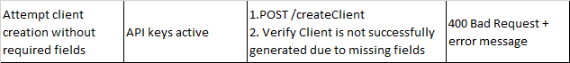
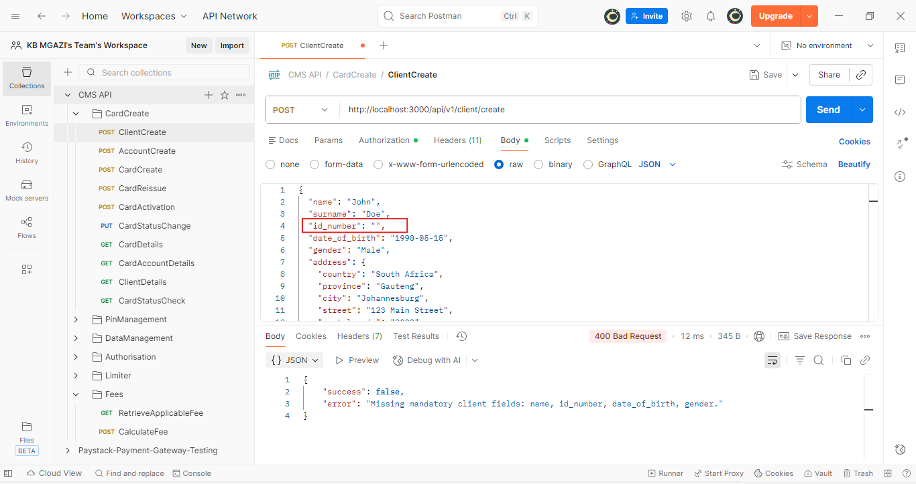
Request:
{
"name": "John",
"surname": "Doe",
"id_number": "",
"date_of_birth": "1990-05-15",
"gender": "Male",
"address": {
"country": "South Africa",
"province": "Gauteng",
"city": "Johannesburg",
"street": "123 Main Street",
"postal_code": "2000"
},
"work_address": {
"country": "South Africa",
"province": "Gauteng",
"city": "Johannesburg",
"street": "456 Business Road",
"postal_code": "2001"
},
"income": 45000,
"tax_number": "1234567890"
}

Response:
{
"success": false,
"error": "Missing mandatory client fields: name, id_number, date_of_birth, gender."
}

